**Design structure:**

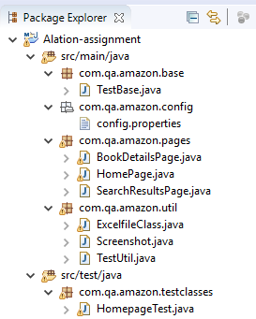

**Packages**

**1. com.qa.amazon.base**

**a)TestBase.java**

* Load configuration file
* Initialize driver for browser
* Instantiate the browser with amazon url
* Implicit wait and Page Load Timeout

2. **com.qa.amazon.config**

* Given the url to be opened
* Browser that to be instantiated

**Both are given as parameter to TestBase.java**

3. **com.qa.amazon.pages**

**a) HomePage.java**

PageFactory.initElements(driver, this);

-This initElements method will create all WebElements

**Methods:**

selectBooksinSearchCategory();->Select Books in search category drop-down

enterSearchKeyword(); -> “Enter data catalog” searchkeyword taken from excel

clickOnGoIcon();->Click on search icon

b**) SearchResultsPage.java**

PageFactory.initElements(driver, this);

-This initElements method will create all WebElements

**Methods:**

verifyResultBasedonsearchKeyword;->Check whether the searchkeyword is listed in navigate section to verify search result displayed are related to the search keyword

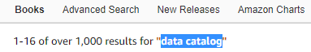

verifyDefaultSortOption (); -> verify whether sorting is done by featured by default

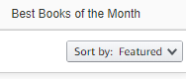

validateproductdetailspage ();-> verify the result count displayed.

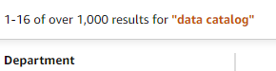

clickFirstResult- Click on the first image

**c) BookDetailsPage.java**

PageFactory.initElements(driver, this);

-This initElements method will create all WebElements

**Methods:**

getBookName->To get the BookName of the selected book

getRatings ->To get the Ratings of the selected book

getPaperbackEdition -> To get the Paperback edition details of the selected book

getKindleEdition-> To get the Kindle edition details of the selected book

getHardCoverEdition-> To get the Hardcover edition details of the selected book

getAuthorName-> To get the Author of the selected book

getAlsoViewedProductDetails-> To get Also viewed product to the selected book

Bookcategory-> To get the Category of the selected book

3. **com.qa.amazon.util**

**a) ExcelUtilClass.java**

getCellData - > To get the searchkeyword from excel

setCellData -> To set the attributes of the book in excel

**b) Screenshot.java**

To take screenshot when the test case fails->has written the method in catch statement

c)**TestUtil**.**java**

provide constant data for the following data variables:

* + - pageloadtime-out
    - implicit wait
    - Excel path
    - Excel file name

3. **com.qa.amazon.testclass**

1. **AmazonTest.java**

**TestNG class to run the methods in a flow**

**@Before class –**  initialization(); method to call initialize method for initiating driver and wait conditions

**@Test-** run the methods in the com.qa.amazon.pages in correct sequence by giving priority

**@After Class-** close the extent and browser

**Test Data.xlsx- > First sheet to get data for search keyword**

**->Second sheet to set data(book attributes) in the excel**

**TestNG xml- > To run the test case as suite**